Redes de Comunicação I

**Project 2024/2025**

Professors: Susana Sargento [susana@ua.pt](mailto:susana@ua.pt) Pedro Rito [pedrorito@ua.pt](mailto:pedrorito@ua.pt)

Victor Marques [victor@ua.pt](mailto:victor@ua.pt)

Students: Afonso Sampaio [afonsosampaio@ua.pt](mailto:afonsosampaio@ua.pt) Paulo Lacerda [paulolacerda@ua.pt](mailto:paulolacerda@ua.pt)

Calendar Inc and Horoscope Inc are two companies that produce digital content for various market segments.

These companies are organized in different departments and functional areas, corresponding to different networks, identified by distinct VLANs, as shown on the diagram below.



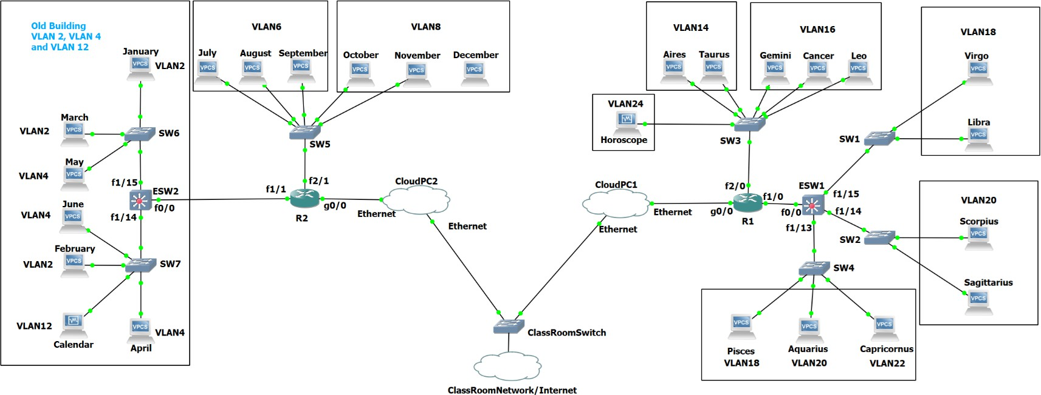

These companies use private and public IPv4 Addresses and Global IPv6.

|  |  |  |
| --- | --- | --- |
|  | **Calendar Inc** | **Horoscope Inc** |
| **Public IPv4 (sub)Network** | **203.157.198.128/25** | **203.020.020.0/25** |
| **Private IPv4 Network** | **172.21.012.0/23** | **172.20.022.0/23** |
| **Global IPv6 Network** | **2002:A197:BC51::/48** | **2002:A202:BC02::/48** |

# Student #1 University Number: 0/1 1 9 7 5 1 X1X2X3X4X5

# Student #2 University Number: 0/1 2 0 2 0 2 X10X9X8X7X6

**(if the project is done by a single student, he/she must use the same student number for #1 and #2)**

These companies use Cisco 7200 and Cisco EtherSwitch (ESWs) Routers.

The Cisco 7200 routers and the EtherSwitchs (ESW) are equipped with the following interface cards:

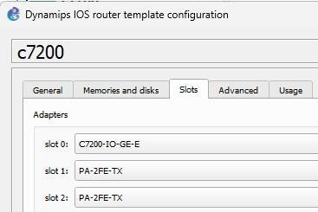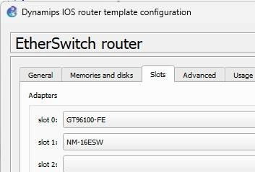

All the remaining network is composed of simple Ethernet Switches capable of handling VLANs.

Calendar Inc uses both Public and Private IPv4 and it also uses global IPv6 addresses inside its several buildings and departments, as explained below.

With respect to VLANs, terminals correspondence and IP address configuration strategy, they are as follows:

|  |  |  |  |  |  |
| --- | --- | --- | --- | --- | --- |
| **Terminal** | **VLAN**  **id** | **Fixed**  **Private IPv4** | **DHCP**  **Private IPv4** | **Fixed**  **Public IPv4** | **Global**  **IPv6** |
| January | 2 | X |  |  | X |
| February | 2 |  | X |  | X |
| March | 2 |  |  | X | X |
| April | 4 | X |  |  | X |
| May | 4 |  | X |  | X |
| June | 4 |  |  | X | X |
| July | 6 | X |  |  | X |
| August | 6 |  | X |  | X |
| September | 6 |  |  | X | X |
| October | 8 | X |  |  | X |
| November | 8 |  | X |  | X |
| December | 8 |  |  | X | X |
| **Calendar (VM)** | 12 |  |  | X | X |
| Aires | 14 |  | X |  | X |
| Taurus | 14 |  |  | X | X |
| Gemini | 16 | X |  |  | X |
| Cancer | 16 |  | X |  | X |
| Leo | 16 |  |  | X | X |
| Virgo | 18 | X |  |  | X |
| Libra | 18 |  | X |  | X |
| Scorpius | 20 | X |  |  | X |
| Sagittarius | 20 |  | X |  | X |
| Capricornus | 22 |  |  | X | X |
| Aquarius | 20 |  |  | X | X |
| Pisces | 18 |  |  | X | X |
| **Horoscope (VM)** | 24 |  |  | X | X |

# Public IPv4

These two companies have, from their ISP, the previous identified public IPv4 sub-Networks. The addresses need to be distributed according to the identified needs (please note that you should consider addresses for the router interfaces on top of the following needs):

|  |  |  |  |
| --- | --- | --- | --- |
| **Calendar Inc - 203.157.191.128/25** | | **Horoscope Inc - 203.020.020.0/25** | |
| NAT/PAT | 2 | NAT/PAT | 3 |
| VLAN2 | 12 | VLAN 14 | 28 |
| VLAN4 | 20 | VLAN16 | 27 |
| VLAN6 | 50 | VLAN18 | 13 |
| VLAN8 | 5 | VLAN20 | 10 |
| VLAN12 | 1 address | VLAN22 | 7 |
|  |  | VLAN24 | 1 address |

# Private IPv4

The companies also use private IPv4 addresses inside its network for internal communication between the teams of the several departments/VLANs. The addresses needed at each location are:

|  |  |  |  |
| --- | --- | --- | --- |
| **Calendar Inc - 172.21.012.0/23** | | **Horoscope Inc - 172.20.022.0/23** | |
| VLAN2 | 200 | VLAN 14 | 25 |
| VLAN4 | 110 | VLAN16 | 55 |
| VLAN6 | 50 | VLAN18 | 57 |
| VLAN8 | 25 | VLAN20 | 10 |
| VLAN12 | 0 addresses | VLAN22 | 155 |
|  |  | VLAN24 | 0 addresses |

# Within each company, the routers interconnections also use private IPv4 addressing from the SAME address pools.



**Global IPv6**

With respect to IPv6, these companies also use IPv6. They both received from their ISP a /48 IP6 prefix.

|  |  |  |
| --- | --- | --- |
|  | **Calendar Inc** | **Horoscope Inc** |
| **Global IPv6 Network** | **2002:A197:BC51::/48** | **2002:A202:BC02::/48** |

These IPs must be distributed following the next rules:

* Each of the routers (including the ESWs) will manage a different /56 subnetwork, taken from the main /48.
* Each department/VLAN must be assigned with a /64, taken from the router that provides its connectivity.
* The interconnections between routers and ESWs must use /126 global IPv6, taken from another /56.

# Inter-company and Internet Connectivity

The R1 Gigabit Ethernet interface 0/0 (g0/0) must be configured with the 192.168.101.172 /24

The R2 Gigabit Ethernet interface 0/0 (g0/0) must be configured with the 192.168.101.150 /24

All terminals (VPCs) and servers must be able to access the Internet, either directly (public IPv4), either via NAT/PAT that must be configured on this same router. The ONLY Exception is for the terminals with private addresses of the VLAN8 and VLAN 18 – These ARE NOT ALLOWED to access Internet.

# Routing

Static Routing must be configured to allow full connectivity between all devices on the network. Default routes must be used when possible.

The Classroom has a router with IP 192.168.101.11, which provides Internet Access. Configure your network to make use of the router.

The ClassRoom router has the IPv6 Address 2002:5755::1/64 and R1 and R2 must have the 2002:5755::02**97** /64 and 2002:5755::02**20** /64 addresses on their interface.

# Phase 1: Distribute the addresses (Public and private IPv4 and IPv6) according to the specifications provided (report by 15/11/2024)

1. Identify the network address and broadcast address (if applicable) for all networks/sub-networks, both for IPv4 and IPv6. Do not forget the addresses of the routers interfaces on each (sub)network.
2. Identify the range of IP addresses for the devices (PCs, routers, etc.) for each network/sub-network.
3. Identify the NAT/PAT networks and range.
4. A close up of a screen

   Description automatically generatedChoose/identify the gateway and/or default gateway address(es) for each network/sub-network, when applicable.



# Phase 2: Configure the network in GNS3 (files/demo by 29/11/2024)

1. Build the Network using the same exact devices and interfaces as presented in the network diagram.
2. Configure the routers interfaces and verify point-to-point connectivity between them.



1. Configure the Ethernet Switches to have them with the correct VLAN configuration (when appliable).



1. Configure DHCP pools for all the private networks on the R1 and R2 routers. Use the “ip helper-address” on the ESWs to redirect the DHCP request to the right server (R1 or R2). Include the DNS server option on the DHCP pool. Use “Calendar” and/or “Horoscope” as DNS server.



1. Configure NAT/PAT mechanisms in R1 and R2. Use the defined ranges of public IPv4 addresses to configure the translation with the private network.



# Phase 3: Add services and applications (files/demo by 16/12/2024)

1. Place the VMs “Calendar” and “Horoscope” (only one VM is required forS projects by a single student).
2. Configure a Web/HTTP Server on those VMs.
3. Create a Web page for each company on the corresponding VM.
4. Develop a Client/Server application (using sockets) that allows a client to contact the server and play the ‘guess the number’ game. When the client connects to the server, it generates a random number configured in an interval; the player, on the client side, tries to guess the number, and the server replies with hints to get closer to the number, or with a winning message. The server must count the number of tries of each client, representing it by its IP address, port and player name.

**Good Luck**